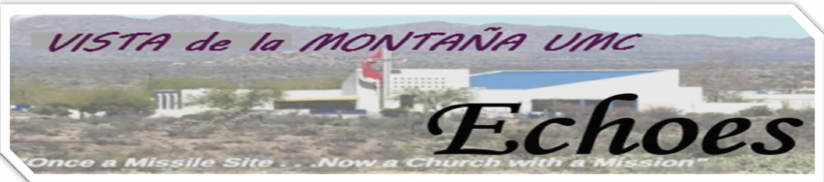

### December 2024

#### Our Mission at Vista de la Montaña United Methodist Church

To make disciples of Jesus Christ for the transformation of the world, and to reach out to others, help them, welcome them into our family of faith as we gather for worship, fellowship, education, and service.



### “Tuesdays with Pastor Mary”

**Remember to tune** into Vista’s Facebook page every Tuesday for a message from Pastor Mary. To access Facebook, go to our website: [www.vistaumc.org](http://www.vistaumc.org/) and click on the Facebook icon.

**Address for ALL Echoes articles!**

The email address for **all** Echoes articles is: [echoes@vistaumc.org](mailto:echoes@vistaumc.org)

Please make sure that you send your articles to that address only! If you send it to another address it is possible the article will not be published.

Nancy Yob, [echoes@vistaumc.org](mailto:echoes@vistaumc.org)

**New Signage for the Campus Entrance**

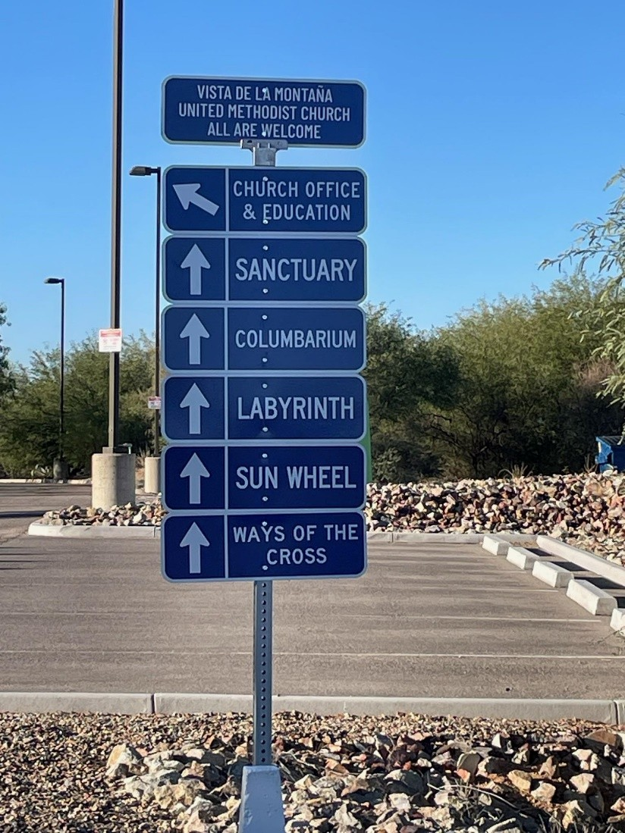



**CHRISTMAS EVE SERVICE**

**& COMMUNION**

**DECEMBER 24th**

**4:00 PM**

**December Office Hours The office will be closed: December 25th & 26th, 2024 January 1st, 2025**

# Dix ers - Fellowship Focus

**ie and Bill Ay**

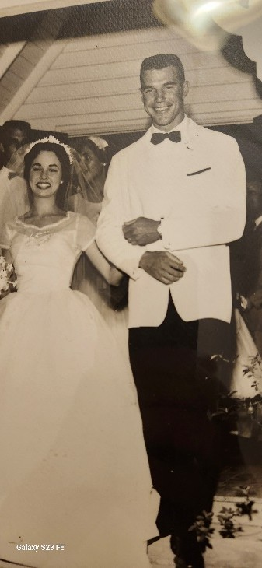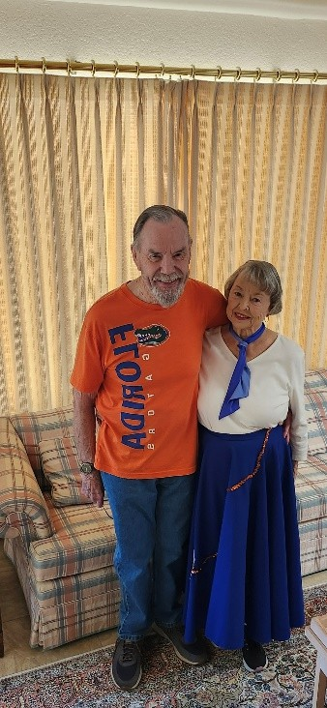

You see their smiling faces quite often around the Vista UMC campus, most likely on Sundays as they cheerfully greet and usher folks attending our service.

Bill and Dixie Ayers are featured in this month’s “Fellowship Focus”. After high school, Bill attended the Apprentice School at the Newport News Shipbuilding and Dry Dock Company in Virginia and played various sports. (Most of America’s aircraft carriers are built there). The College of William and Mary, located close by in Williamsburg, had a football team as well and their coach would visit the Apprentice School practices when his team wasn’t playing. He offered Bill a football scholarship at William and Mary.

Since Bill had completed high school in Florida and followed the Gators, he thought perhaps they too could offer him an athletic scholarship as well. During the summer, Bill and his dad drove to Florida and asked for a scholarship at the University of Florida. Several high schools wrote letters on his behalf. They timed him running and threw him passes, amid other athletic skills and Bill and his dad sat at the training table with all the players going to summer school. The coach, Bob Woodruff, said he appreciated them coming down and said he would let them know. Bill returned to the Apprentice School and two weeks later he received a letter from Coach Woodruff offering a full four-year scholarship. He was accepted and enrolled at the University of Florida.

In his second year, Bill visited the girls’ dormitory to help the new arrivals with the luggage. After completing that task, he went inside to the recreation area and noticed Dixie talking to a baseball player. She looked up and smiled at him. She was a transfer student from Gettysburg College after her dad’s completion of his Naval career and retirement in Florida with the family.

They started dating and Bill states she liked to have lots of notice. A few times he asked too late and she already had another date! Finally, Bill got the message and asked in time.

He was in ROTC as an officer and sent to Fort Belvoir in Virginia. They decided to wait until she graduated to get married. She was student teaching in Jacksonville, FL. Bill caught military flights in Washington DC to fly down for visits. After their marriage, there was no military housing available. They lived in an apartment in Alexandria for several months before renting a house near Mount Vernon. Dixie joked that it used to be slave

quarters (Bill states that “it wasn’t that bad”.) While Bill fulfilled his Army military obligation, she taught 2nd grade at the local school.

Afterwards, Bill was hired by Lusk Corporation and began his construction career in Tucson, Arizona. Dixie continued teaching as they followed the job market for the next 65+ years. (Those years included projects from houses to high-rise office buildings, including the Arco Tower and Glen Lakes Tower in Dallas. He went to Russia to inspect office buildings that AIG was planning to buy. He went to Latvia to work on a hotel and to Brazil to search for sites to build Walmarts. After retirement in Birmingham, AL, he was asked to supervise construction of several tilt-wall warehouses in Memphis, TN, including one of 1,000,000 sq. ft.

Their full life includes a daughter, Heather (born in Phoenix) and a son, Lance (born in Albuquerque).

Bill and Dixie have been an integral part among Vista UMC members since 2015 and have served on several committees. Bill has been a Trustee including being responsible for setting up and taking down items in the old buildings. He also volunteered with the Landscape crew. Dixie is part of the Zoom discipleship, Shepherds and a member of Women of Faith ministry. Currently, the couple participates in ushering and communion services.

--Robin Conner

# *“Share the Warmth” Clothing and Bedding Drive – Get Ready!*

Vista’s annual Warm Clothing and Bedding Drive will run from Sunday, December 15,’24 through January 26, ’25. Please consider supporting this cause with donations of gently used (or new) clothing and/or bedding. All donated items are regularly taken to IMPACT in Catalina, where they are distributed to neighbors in need in our community. Socks, sweaters, jackets, gloves and head coverings are especially appreciated, as are blankets and quilts. A clearly identified box in the narthex is available for your donations. Thank you in advance for your support during this season of giving (cash donations also gratefully accepted).

# Contact Benith MacPherson ([benithmac@aol.com](mailto:benithmac@aol.com)) with questions

# Mission and Outreach

*Behold, I am doing a new thing; now it springs forth, now it springs forth, do you not perceive it?*

# IMPACT of Southern Arizona

We are continuing to grow our ministry outreach with Impact Food Bank of Catalina. In recent weeks, I have been in contact with Cody Wilkinson the Director of Feeding Programs. In response to the question, “What are your immediate needs for the holiday season?” He suggested purchasing a pie for each of the forty shut in seniors they serve daily. With Your generous donations totaling $126, we purchased and delivered 80 pies—one pumpkin and one apple for each person. Thank you church for supporting ***$2 Buy a Pie*** .

**Another need:** Cody has also stated that they are in need of folks to pack food boxes on a regular basis. I will be meeting with him in January to pursue this further.

# Food Bank and Loose Change Ministry

**Impact Food Bank:** Your monthly donations make a huge difference! Thank you church for your continued support of our local food bank. Last month 32 lbs. of food was donated.

**Loose Change Ministry:** This end of the month collection of loose change and small bills really made a difference. In September, $212.25 was collected and donated to the Coronado Teacher’s Appreciation Fund. With your generous donations we were able to supply candy for their annual Trunk or Treat event.

--Linda Galka

# UNITED WOMEN IN FAITH

United Women in Faith assembled Children's Art Packs and toiletry kits in November to be given to local Tucson charities. Christmas stockings will be distributed on November 24, December 1 and 8 at church. These stockings, filled with toiletry and personal items, will be given to Eagles Wings of Grace, TMM, and Family First. Our final fund-raiser of the year will be a bake sale on Sunday, December 15, before and after church. Your support of United Women in Faith (formerly United Methodist Women) is greatly appreciated.

REMINDER: Christmas stockings will be distributed December 1 and 8 at church. These stockings, filled with toiletry and personal items, will be given to Eagles Wings of Grace, TMM, and Family First. Our final fund-raiser of the year will be a bake sale on Sunday, December 15, before and after church. Your support of United Women in Faith (formerly United Methodist Women) is greatly appreciated.

--Amy Butkovich

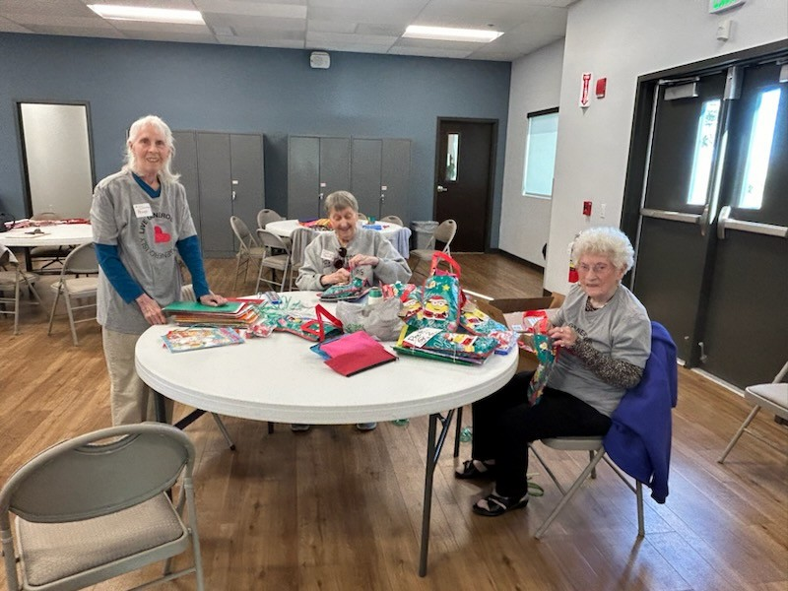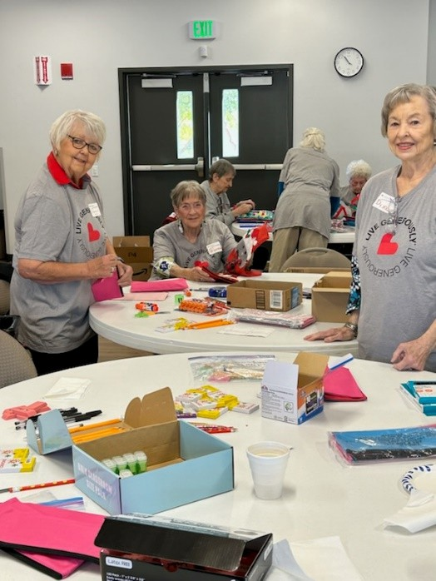

Volunteers sorting Children’s Art Supplies and Toiletry Kits.

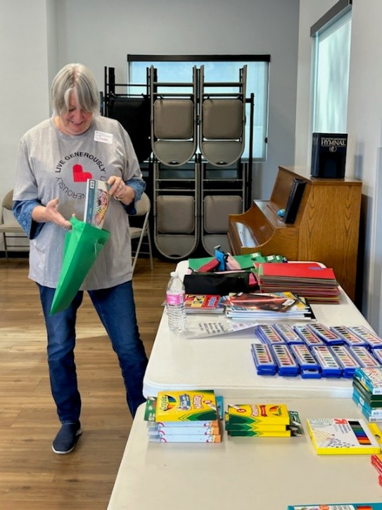 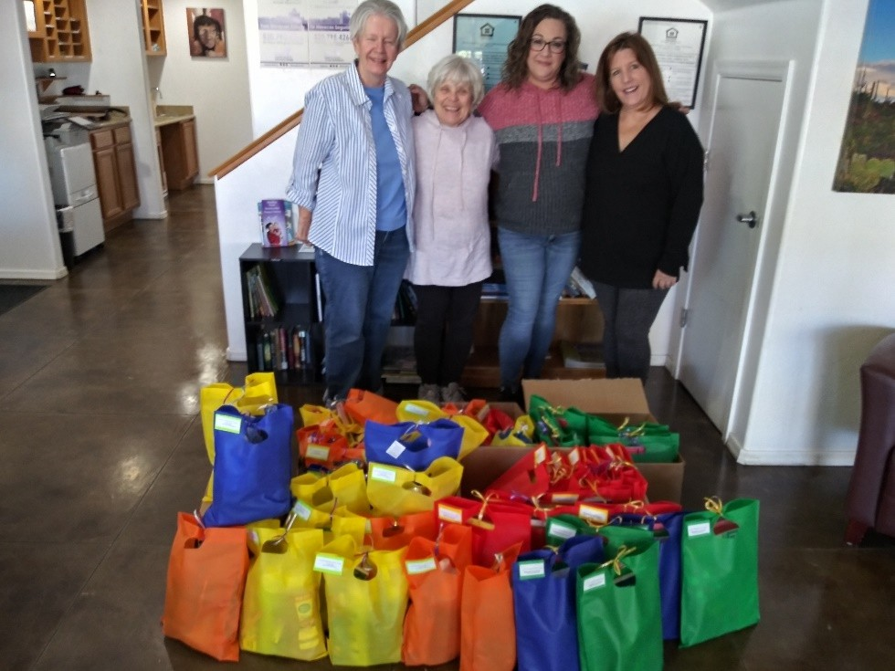

Amy Butkovich & Jan Millard with Annie Mitchell, Administrative Assistant, Christie Lee, President/CEO from Tucson Metropolitan Ministries.

# SNAK PAK PROGRAM

Vista UMC is answering the call to feed hungry tummies through our SNAK PAK Program at the Coronado K-8 School here in Catalina. In concert with the Santa Catalina Catholic Church, we help to provide weekly weekend meals/snacks to 60 students who might otherwise have limited or no foodstuffs to eat while away from the school environment.

Volunteers from both churches and local neighborhoods gather at the school at the last Wednesday of each month to pack 240 bags to cover these 60 students for the course of one month. These students have been selected by the school social worker based on eligibility and greatest need.

## STEWARDSHIP REPORT

Total pledges to date: 53; for a total of $172,825. Sharon indicated we should get 25-30 more for about $60,000. The average is $3,261. There were 7 decreases, 18 increases and 20 stayed the same. Also, 8 new pledges. Last year by this time we had 60 pledges for $209,480. The final total was 92 for $301,000. The average was $3,271.

Jim Galka

Stewardship Chair

***The Vista youth & their “Friends” (aka the Big Kids) & Sierra Yob’s Ironwood High School Key Club members are making keychains to be donated to several organizations through Vista’s Outreach Programs.***

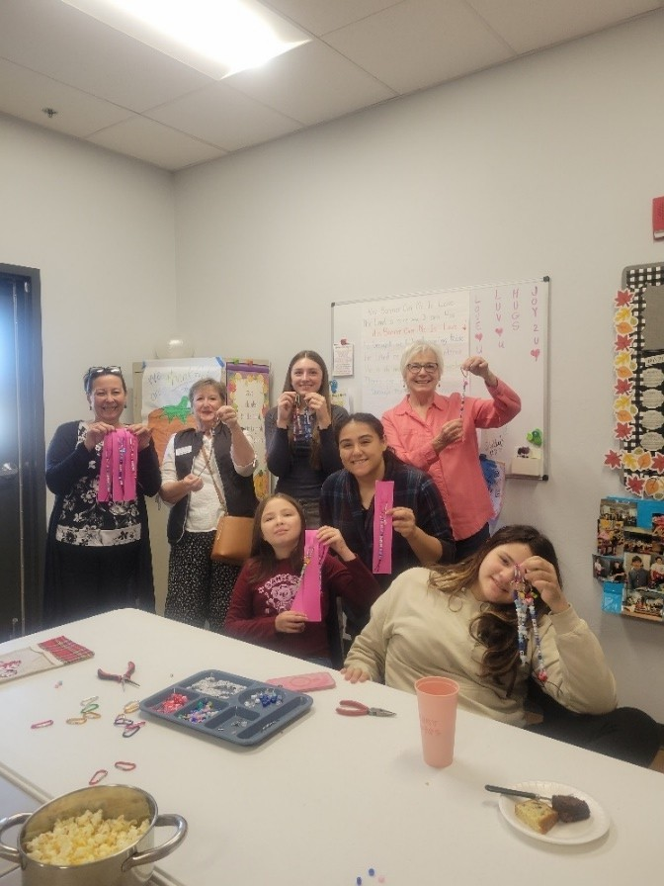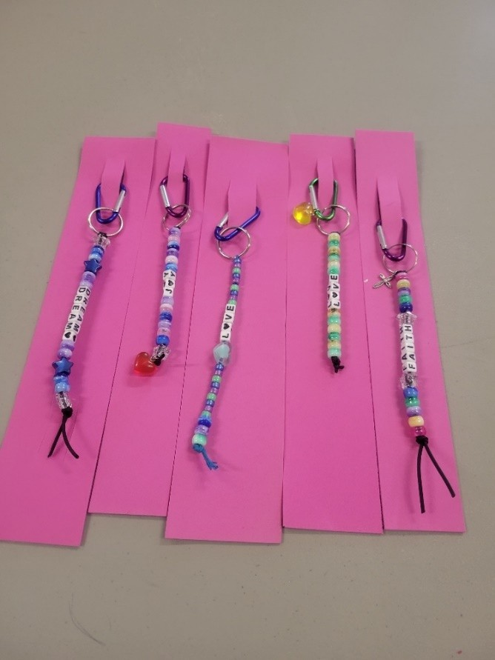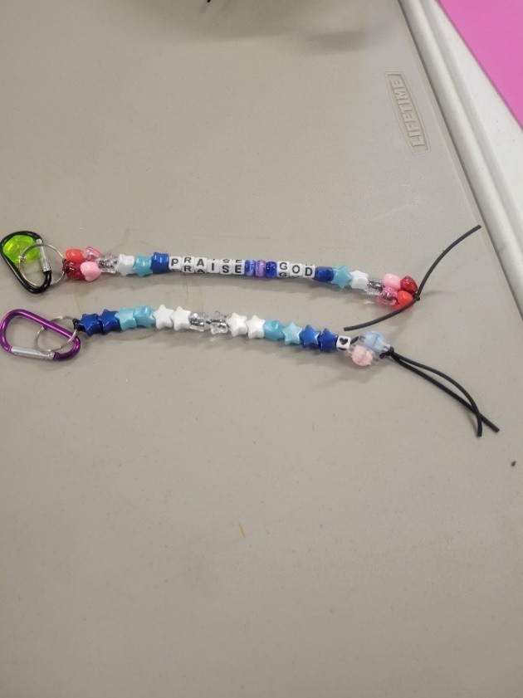

**STILL TIME TO JOIN US!**

**Vista UMC Advent Class - Cards from the Characters of Christmas**

**SHARON SCANLAN & DONNA BORING**



Advent is almost upon us. And yet our world, like that of the world in Jesus’ time, is fraught with problems, worries and anxieties. Into this web of issues came Saint Luke the Evangelist’s magical story of the birth of Christ. Chapter 2 of the Book of Luke tells us the story of the birth of Jesus in Bethlehem. Our class will focus on the characters of Christmas, and what their stories might have been like. What characters you ask? Besides Joseph, Mary and the baby Jesus, we have the shepherds, innkeepers, citizens of Bethlehem, the wisemen, Caesar Augustus, Quirinius, the Angel of the Lord, Simeon, and Anna. All have a part to play in the coming of the long-promised Messiah. After 400 years of silence God delivers on his promise.

This Advent Study uses several sources to imagine what these people may have been like. Each class will include letters and stories that the characters could have written but didn’t, in order to facilitate group discussion on Luke Chapter 2 and its significance to the world. The class promises to be entertaining, as well as thought provoking.

All are welcome to attend. The class is offered at 10:00 AM on Wednesdays during Advent at the Vista United Methodist Church at 3001 East Miravista Lane, Tucson Arizona 85739 in the Saint Elizabeth Room of the Administrative and Education Building. Classes start on November 20th, skip November 27th for Thanksgiving and resume on Wednesdays until the last class on December 18th. If you wish to attend, please call 520-825 -985 and leave your name and how to get ahold of you. Ask the receptionist to deliver the message to Donna Boring.

Vista UMC’s classes are open to everyone! The church is located on the west side of Oracle Rd., just south of the Golder Ranch stoplight.

# Arizona 3-day Academy for Spiritual Formation

* **April 22 – 25, 2025**
* **Singing Earth’s Song: Lament, Praise, Prayer**
  + **“The earth is the Lord’s and the fullness thereof; the world, and they who dwell therein.” Ps. 24:1. The environmental crisis demands a response from the faith community, because the problem is not just a scientific or political problem; it’s a spiritual problem. Materialism dictates our value system; we’re short-sighted about the use of the earth’s resources. Local churches have often chosen denial or complacency rather than hope and engagement, even though the environment is often the number one concern of our young people. This retreat is a journey into the heart of our faith tradition and the scientific community as together we find ways to respond.**
* **FOR MORE INFORMATION and TO REGISTER, go to** [**https://dscumc.org/3-day-**](https://dscumc.org/3-day-academy-for-spiritual-formation-april-22-25-2025/)[**academy-for-spiritual-formation-april-22-25-2025/**](https://dscumc.org/3-day-academy-for-spiritual-formation-april-22-25-2025/)**.**
* **REDEMPTORIST RENEWAL CENTER (**[**https://desertrenewal.org**](https://desertrenewal.org/)**) – here in Tucson.**
* **Faculty Presenter – Rev. Molly Vetter**
* **Science Consultant – Dr Gary Paul Nabhan**
* **RETREAT TEAM**
  + **Rev. Jerry Haas, Retreat Leader** [**jndhaas@gmail.com**](mailto:jndhaas@gmail.com)
  + **Rev. Susan Morgan, Theologian**
  + **Rev. Tweedy Sombrero, Spiritual Guide**
  + **Gail Parson, Hospitality**
  + **Joe Hill, Worship Coordinator**
  + **Derrick, Accompanist**

**Gail Parson – please feel free to contact me with any questions you have about this event.**

**Call or text (520) 275-7117 email** [**gailma@comcast.net**](mailto:gailma@comcast.net)

## Endowment

#### Tax-Advantaged Year-End Giving

At this time of year, whether you are young or older, many of us are thinking about how to minimize their tax obligation for 2024. Charitable giving is but one way. Donating to Vista’s Permanent Endowment Fund reduces your taxes, supports special programs at Vista, and creates a legacy of your faith journey.

Outlined below are several methods to consider when contributing to the Endowment Fund.

**Qualified Charitable Distribution (QCD):** If you are fortunate enough to have an Individual Retirement Account (IRA) and are of the age to require a minimum distribution (RMA), you may direct all or a portion of the distribution to Vista’s Endowment fund. To assure the tax benefit, the donation must go directly to the charity, not to the account owner or a Donor Advised Fund (see below). The maximum donation is $105,000. If your spouse has a separate IRA, they may also donate up to $105,000.

**Donor-Advised Fund (DAF):** A DAF allows donors to contribute assets to a tax-free investment account from which they can direct gifts to charities of their choice. The total contribution to the investment account provides a charitable income tax deduction in the year it’s made. Subsequent distributions from the account to charities of your choice are not tax deductible.

**Appreciated Stock:** Donation of appreciated stock is a tax-efficient way to benefit Vista’s Endowment Fund. Donors avoid the capital gains tax associated with the stock appreciation and receive full market value of the shares donated as a tax deduction.

# Celebrating Sandy and Pete Schwartz 65th Anniversary

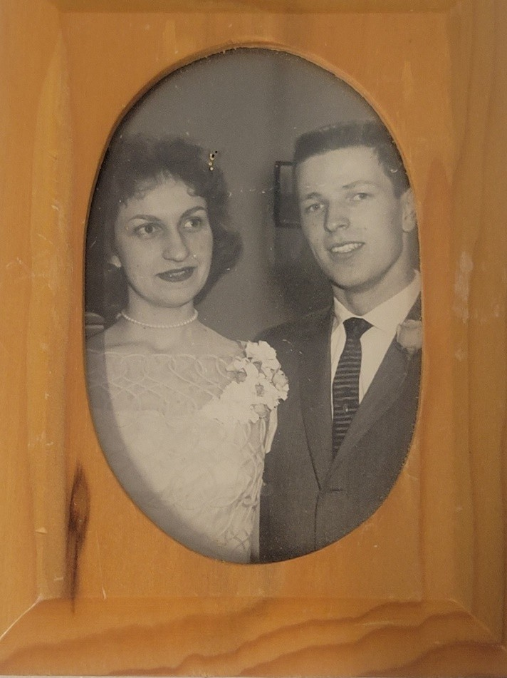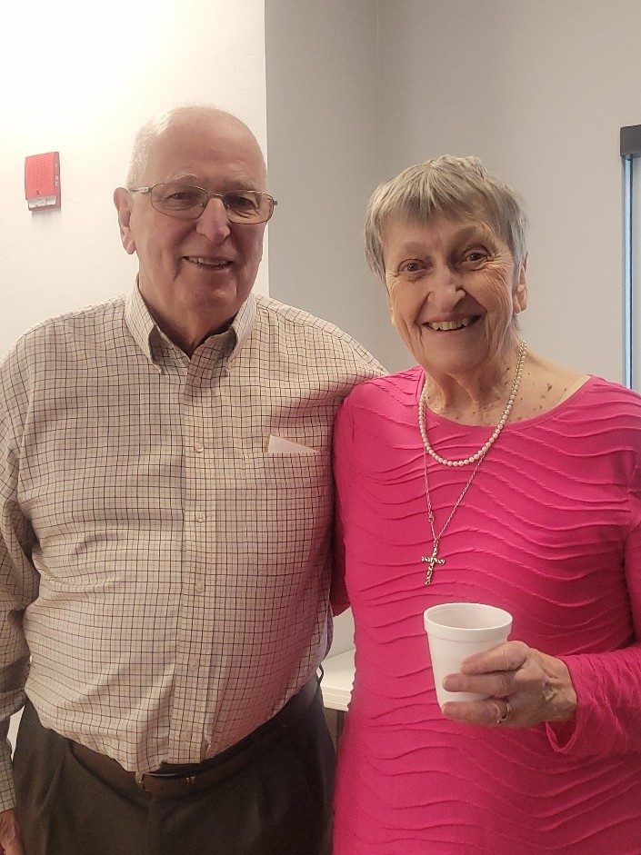

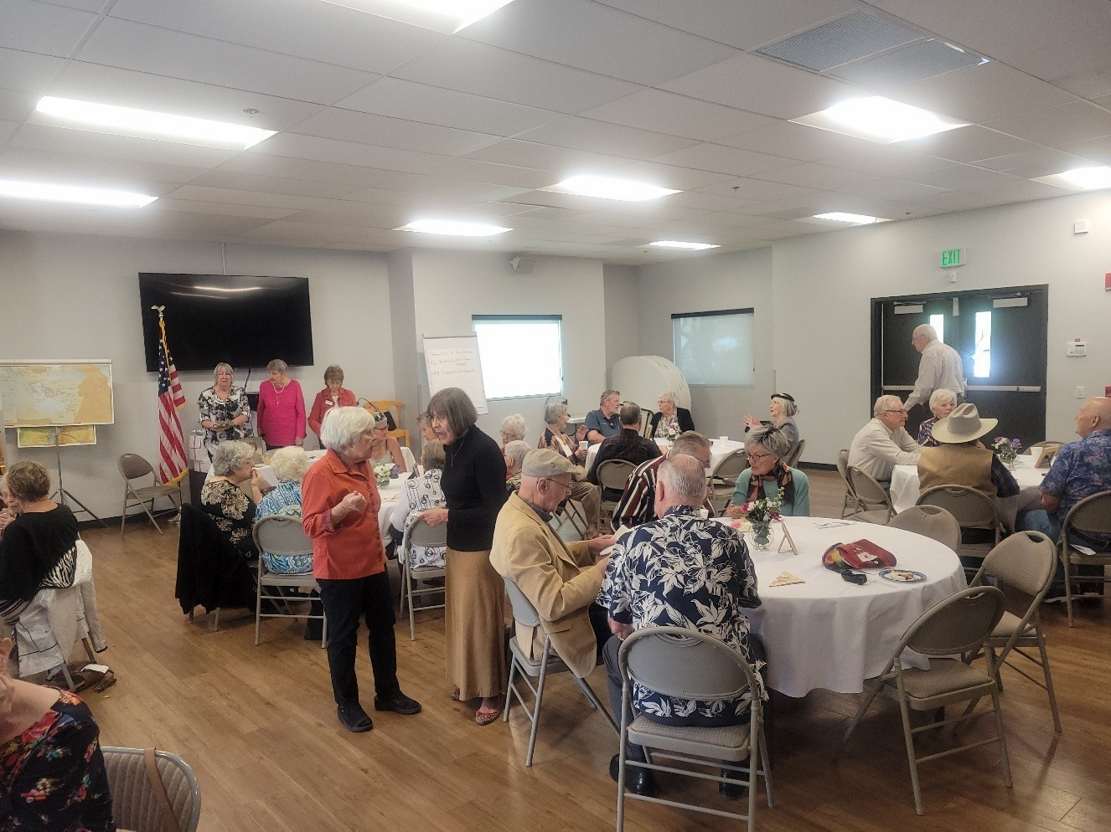

**MUSIC: WINDS AND STRINGS CONCERT**

The SaddleBrooke Winds and Strings presented a concert at Vista UMC on Sunday, November 17th as a thank-you for letting them rehearse on the church campus.  This sampling of their current repertoire provided attendees with an enjoyable variety of upbeat music ranging from Bach to popular music of the 1920s to modern concert band music.  Although the concert was performed for free, attendees donated generously to the group, and all monies collected were donated back to the church's music programs.

SaddleBrooke Winds & Strings started as a "garage band" in 2013 and has evolved into a community group consisting of amateur and professional musicians from SaddleBrooke and surrounding areas.  They even claim a 100-year-old trumpet player as a member!  Their conductor, Jesus Jacquez, is an active musician in southern Arizona, and is an experienced band and orchestra teacher.

Catch them in their next "Winter Potpourri" concert December 21st at 6:00 pm at the Desert View Performing Arts Center in SaddleBrooke.

--Carolyn Dwyer

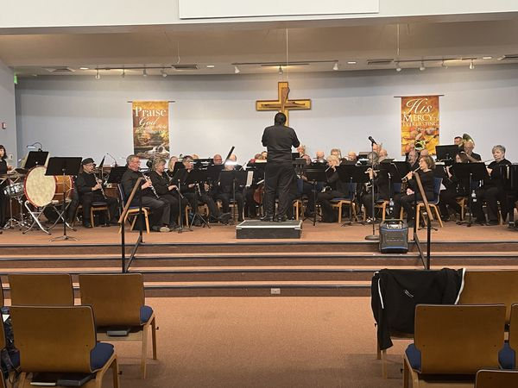

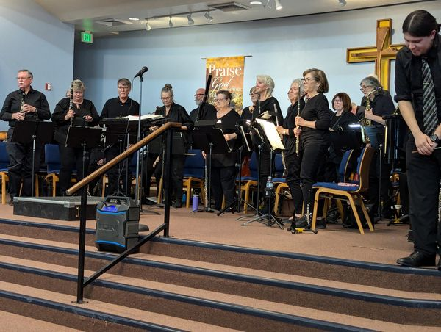

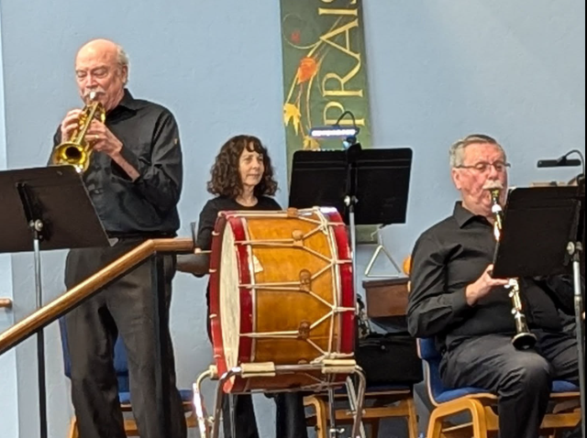

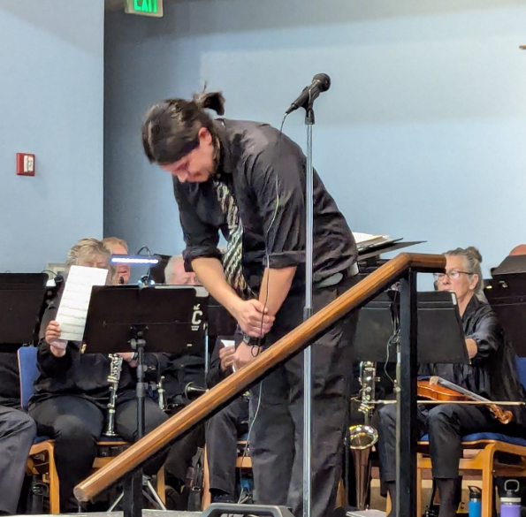

**Have You Visited Our Vista Library?**

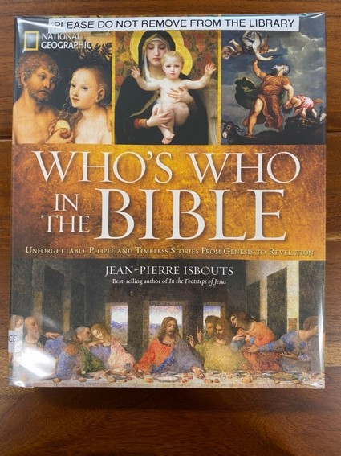

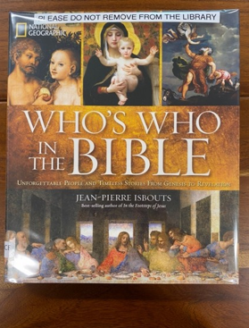

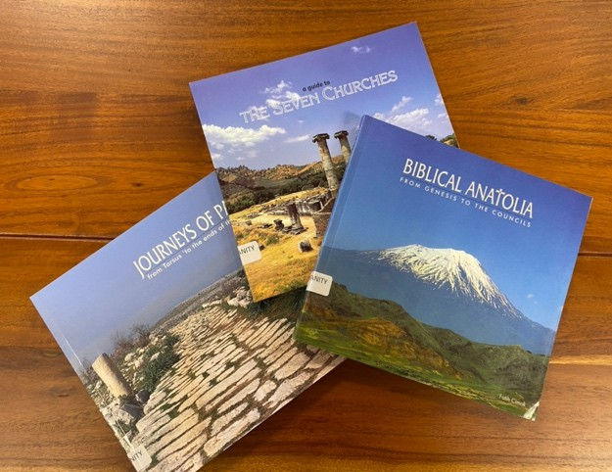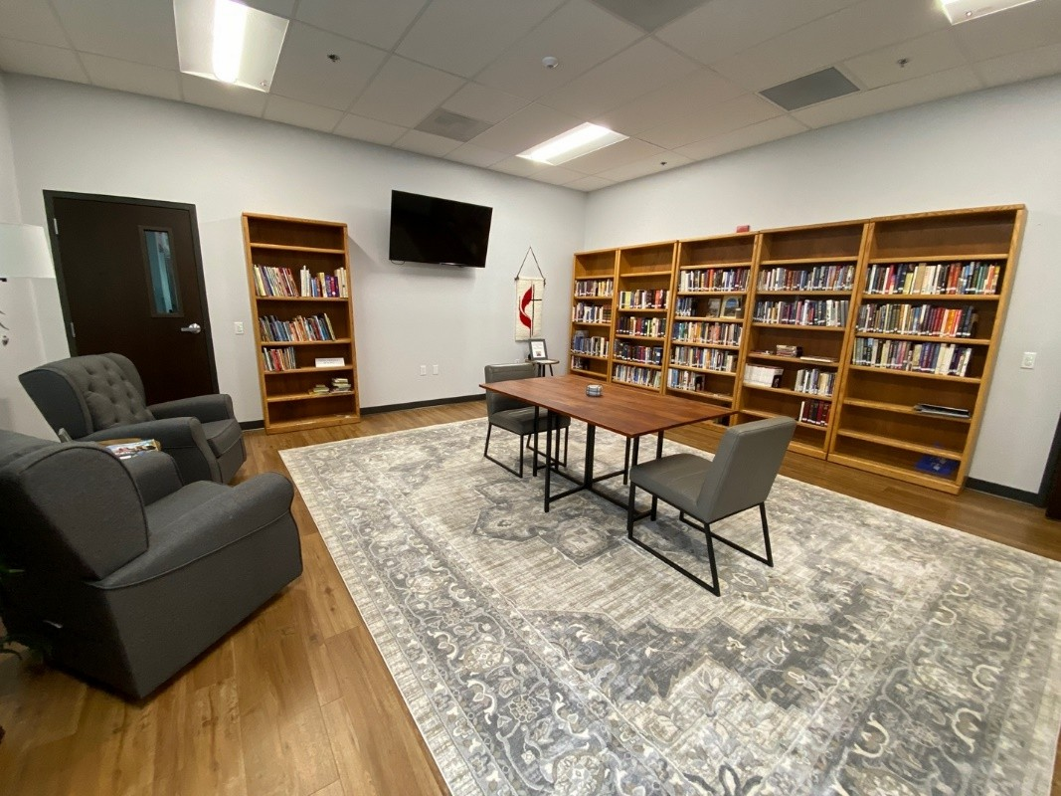

Our new library is for you to enjoy. In January, the Women’s Lectionary Class, with the help of the Trustees, set up our new library and continues to maintain it. It’s a peaceful, meditative space to spend some quiet time and also enjoy the great selection of books in our collection. They are arranged by category, so it’s easy to find a book that interests you. The library operates on the Honor system, so you don’t have to check it out!!

We have had many wonderful donations! Recently Sandy and Pete Schwartz’s neighbor donated the “National Geographic Who’s Who in the Bible”. It’s a new version of a very popular reference book. Jane Hendrickson, who is new to Vista this year, donated 3 excellent books featured in the photograph. As Jane said, “if I want to read the books again, I can get them out of the library!” We encourage donations of books and DVDs. You can leave them in the Donations box. Also available during office hours are greeting cards and prayer beads. If you want a donation receipt, email Sharon Scanlan at [sascanlan8548@me.com.](mailto:sascanlan8548@me.com)

### December 2024 Birthdays

**January 2025 Birthdays**

### 





|  |  |
| --- | --- |
| HOLDEN, Larry | 01/02 |
| HERNANDEZ, Antonio (AJ) | 01/03 |
| REIFSNYDER, Walter | 01/05 |
| AUTHUR, Janelle | 01/07 |
| HIGGINS, Dennis | 01/07 |
| PRICE, Ursula | 01/08 |
| DEVRIES, Shirley | 01/12 |
| TONGA, Mia | 01/14 |
| COLEMAN, Diane | 01/15 |
| MEISE, Stan | 01/16 |
| CONNER, Robin | 01/17 |
| REIFSNYDER, Jane | 01/18 |
| FOWLER, Valarie | 01/21 |
| DAVIS, Linda | 01/22 |
| YOB, Nancy | 01/23 |
| CHRISTINE, Deborah | 01/25 |
| AGUIRRE, Michelle | 01/28 |
| THOMPSON, Sara | 01/29 |

|  |  |
| --- | --- |
| MILLER, Shirley  KOELLING, Jerry  LENZINI, Alice Ann  WATKINS, Stuart  BOLAR, Marlin  SMITH, Kathleen  AGNEW, Jean  MILLER, Paul  DE WINDT, Charlotte  GRIFFIN, Linda  BONNEAU, Edward  RUPE, Marvin  CARTER, Charlene  MC FARLAND, Glenda  LITTLE, Betty  SMITH, George | 12/01  12/05  12/05  12/09  12/10  12/10  12/16  12/17  12/22  12/23  12/25  12/25  12/27  12/28  12/30  12/30 |

**December Anniversaries**





**January Anniversaries**

SMITH, Don & Pat 01/01

|  |  |
| --- | --- |
| O’DONALD, Jay & Louise | 12/01 |
| NEVINS, Dick & Ilene | 12/08 |
| MILLER, Linda & Ray | 12/16 |
| FLOYD, T.J. & Linda | 12/28 |

SMITH, Don & Pat 01/01

**SAVE THE DATE!!**

**SUNDAY, DECEMBER 15TH, AFTER CHURCH**



**PLEASE BRING THE FOLLOWING: A-G: DESSERTS**

**H-N: SIDES, SALADS,**

**OR APPETIZERS 0-Z: MAIN DISHES**

**We appreciate volunteers for the following duties:**

* **Set up Elizabeth Room on Saturday**
* **Beverage service in Elizabeth Room**
* **Transporting food to Elizabeth Room after service**
* **Placing dishes on appropriate tables in Elizabeth Room**
* **Assist folks as needed during potluck**
* **Clean up after event; transporting back to kitchen**
* **Monday: cleaning up excess dishes, etc.**

**THANK YOU TO OUR YOUTH FOR DECORATING PLACEMATS!**

**Contact Kathy Isaac:** [**ktisaac@aol.com**](mailto:ktisaac@aol.com)

**or Robin Conner:** [**robin.mikeconner@gmail.com**](mailto:robin.mikeconner@gmail.com) **with questions**

**And yes, this is the same date as Women’s Bake Sale, before and after church!**

## Compassion Connection

##### In Need of Continued Prayers for Healing

Eileen Carender, Edith (Edey) Gallaher, Kay Gragg, Bob & Eileen Herd,

Ken & Sharon Hunt, Betty Little, Allen & Barbara Phillips, and Art Schweitzer.

##### Home Bound

Dr. Chuck Crown, John & Jan Crown, Florence Duckett, Bill Gureck, Fran Hampton, Margaret Overman, Ken & Diane Podlasek, Sharon Poole, Walt & Mary Louise Roberson, and Howard & Mary Lou Young.

##### Prayers for Comfort

The family of Pam Holder who passed away November 10, surrounded by her family in Spokane, Washington.

##### Prayers for our Churches

Each month churches in the South District pray with and for each other. This month we pray for the pastors, congregation, and community of the following: UMC of Good Shepherd, Kearny

UMC of Green Valley, Green Valley

UMC of Willcox, Willcox

Our sister church, Fuente de Vida in Agua Prieta, Mexico.

**Agua Prieta greeting cards** are available for 50¢ each in the library during office hours.

**Complimentary Prayer Beads** are available in the Narthex and in the library.

**Upper Room booklets** are available in the Narthex and the church office for $2.00 each or online at upperroom.org. It is free to sign up for a daily devotional email.

The church has purchased a **Wheelchair** to be used during worship if needed. The wheelchair will be kept in the Narthex.

**Handbell and Chancel Choirs** have begun Wednesday rehearsals. **Handbell Choir** meets at 11:00 am and **Chancel Choir** meets at 1:00 pm. Come and be musical with one or both great groups of people! Contact Carolyn Dwyer, Director of Music Ministries, if you have questions.

***The Santa Catalina Mental Health Ministry’s next Mental Health Focus* will be December 8th at 1 pm** in the Parish Hall at 14380 N. Oracle Rd. Fr. Huy, C.Ss.R, pastor at Santa Catalina Catholic Church, and Dasa Schmidt, Treatment Placement Specialist at Acadia Healthcare, will be presenting.

Join us to learn how to understand the difference between the holiday blues and depression, when to get help and how to help a loved one experiencing depression. Learn that it’s OK to not be OK during the holidays and ideas to find new traditions.

We will also discuss the Church’s compassionate response, inspired by the United States Conference of Catholic Bishops’ (USCCB) ongoing campaign to end the stigma surrounding mental health. We will explore how the Church is working to support individuals and families affected by mental illness, including those impacted by suicide, offering healing, forgiveness, and hope through God’s endless mercy. Learn how our faith community can be a place of understanding, support, and accompaniment for those who are struggling, and discover the Church’s commitment to helping those in need.

All are welcome!

***Service and Volunteer opportunities.***

* AV Booth members needed
* Shepherds needed (contact Robin Conner)

**How to contribute to the offering if online:**

1. Open the camera app on your cell phone.
2. Focus the camera on the QR code by gently tapping the code as it
3. Appears on your camera.
4. Tap on the yellow button—myvanco.com
5. Fill in the card, amount, etc.

***Thank you for your donation!***

#### Hark! the Herald Angels Sing

**One of Charles Wesley's most famous hymns is "Hark! The Herald Angels Sing" written in 1734. This hymn is meant to be sung at Christmas time and celebrates the birth of Jesus.**

**He wrote of “peace on earth and mercy mild, God and sinners reconciled.” The third stanza of this hymn is considered to be the most powerful:**

**Hail the heav’n-born Prince of Peace! Hail the Son of Righteousness!**

**Light and life to all He brings Ris’n with healing in His wings Mild He lays His glory by**

**Born that man no more may die Born to raise the sons of earth Born to give them second birth Hark! The herald angels sing “Glory to the newborn King!**

**Christ was “born to give us second birth.” And that, according Charles and John Wesley, is the true meaning of Christmas.**



A Sun City neighbor enjoying the Christmas lights!!! Thanks, Linda Bretz!



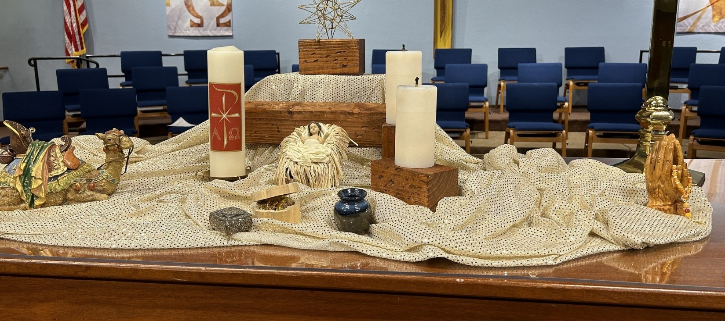

"May the true spirit of Christmas shine in your heart and light your path."

